Empoweren Users Manual

Overview & Admin Area

Welcome
Welcome to the Empoweren Content Management System. With Empoweren, you will have the ability to quickly modify, add, or remove content from your website. This training manual will provide you with a comprehensive overview of how to use the features available in every area of Empoweren, but we also have a full staff of professionals to support your web design and development efforts.

Administrative Overview

Software Needs
While Empoweren is a self contained, hosted software solution, it does utilize XStandard, the leading standards-compliant WYSIWYG editor for desktop applications and Web-based content management systems.

To use Empoweren, you must download a FREE copy of this editor here http://www.xstandard.com/en/downloads/.

Log In
To begin using Empoweren to edit your website, you will need to log in using the username and password provided to you by one of the Empoweren developers. If your website is up and running on Empoweren, the administrator login page will be http://yourdomain.com/empoweren/. Shown below, you will see the Empoweren login page with your company logo on the left side of the box. Enter your username and password and select “Login”.

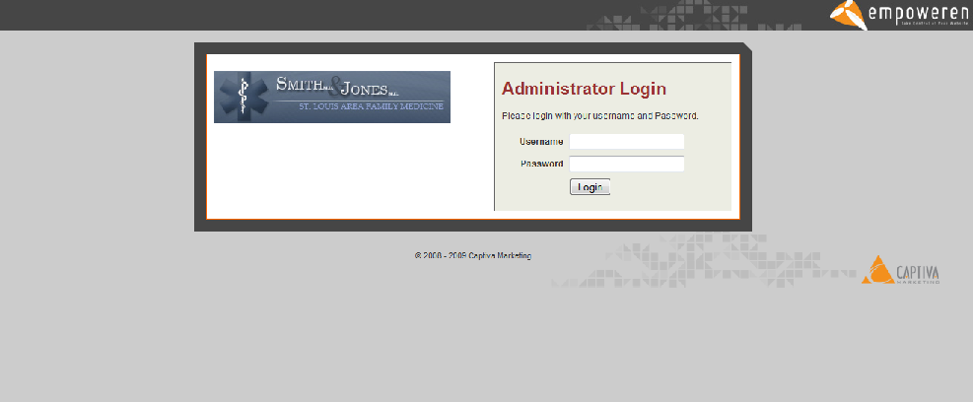
Empoweren tracks who logs into your site so that all changes can be monitored.

Home
Now that you have logged in, you will see all of the modules available to you from the home page. Shown below in Figure 2, the top left has three tabs: home, profile, and logout. In the center area, you will again see your company logo with buttons below for the different modules you can use as well as a box to the right showing what recent updates have been made to the site.

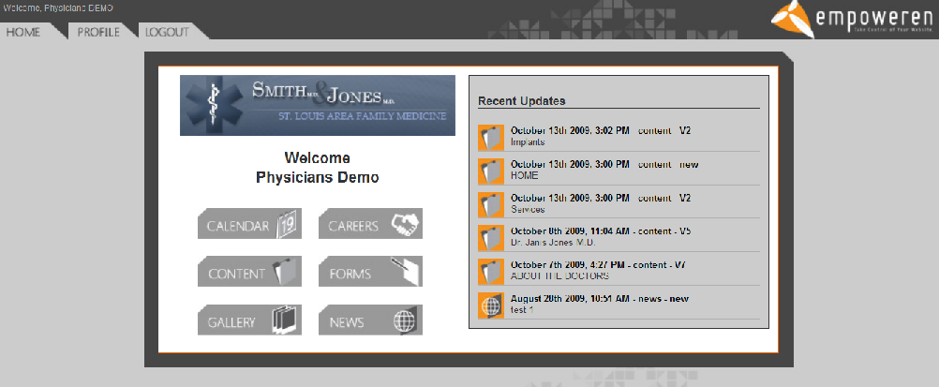

Profile
When the profile tab has been selected in the upper left corner, you will see a screen like the one shown below. This will allow you to change your first and last name, email address, and password. After any changes have been made, select the “Save” button and you will be returned to the home page.

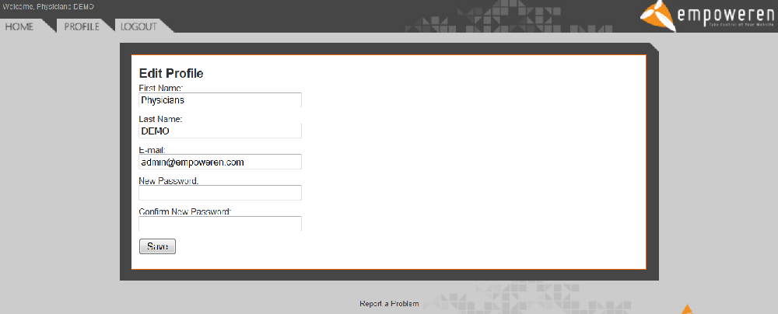

Limited Access
With every profile created, Empoweren Administrators can give specific user accounts access to limited modules, or even down to a specific page.

For instance, if you would like your HR director to only have access to the Careers module, it can do that. If you would like an intern to only have access to a promotions page, it can do that too.

At this time, access must be set up by Empoweren staff.

Logout
Any time you wish to end your Empoweren session, simply select the Logout tab in the upper left corner and your session will be ended, taking you back to the login page.

