Calendar Manager
Users Manual
Calendar

The calendar module of Empoweren is the platform where users can publish company events, industry related events, or community happenings to keep audiences up to date on events that are important to them. This function allows users to create, edit, and organize events in a calendar view that is easy to read and navigate through. From adding images to linking to other pages, users have all the options the WYSIWYG editor has to offer in the calendar module.

Create an Event
The main page of the Calendar section has a small month view calendar on the left and below the calendar is a link that says “Add an Event.” After you click on the link, a new event field will open on the right, where all of the details for the event can be added as shown below.

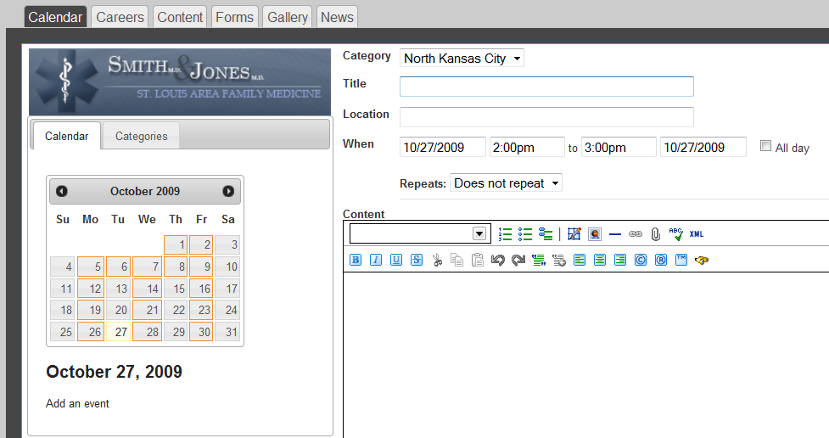

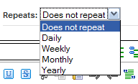
The title is the name of the event that will appear on the calendar or in the event list, depending on the view selected. You also have the option to set the date and time for the beginning and end of the event or create an all day event. If the event is repeating, there are several options in the drop down menu to select from (shown right).

Details, descriptions, photos, links, and more can be added to the event within the WYSIWYG editor. Once the event is complete, click Save at the bottom. If you already have a calendar in place on the site, the event will automatically be added. If you don’t have a calendar on the site yet, read the Inserting section below to learn how to do so.

Users can also add a meta description and meta keywords to each individual event. Although these will not be as important to add as your content pages, it certainly does not hurt to add this information. We would recommend adding meta data to significant events that are scheduled well in advance. However, for smaller events that might not even be indexed by the search engines before the event takes place, adding meta information might not be necessary.

Edit and Delete Events
Once an event is saved, days where events are scheduled will be highlighted in orange indicating that you have entered information. All events in the month will show as a list. You can either click on the day highlighted in orange on the calendar then again on the event that will show below or click on the event in the list on the right of the page to edit or delete an event. If you have the calendar inserted on a page these updates will be live and instant once the user clicks “Save Event” or “Delete Event.”

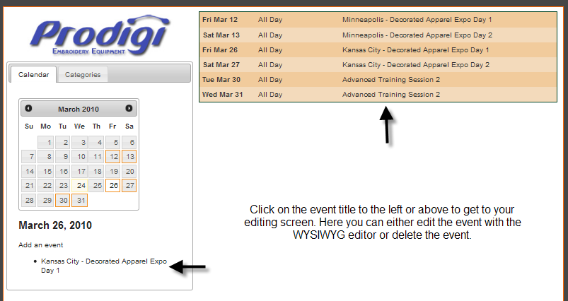

Categories (Enhanced)
Empoweren will automatically have one category for a calendar, but multiple categories can be created in the Enhanced Calendar. With the Enhanced Calendar you can add and delete categories by clicking on the Categories tab while inside the Calendar section. Once in the Categories section, click on All Categories and use the menu icon to manage your categories. Users will have the option of which categories they would like displayed on the front end when inserting the calendar manger onto a page.
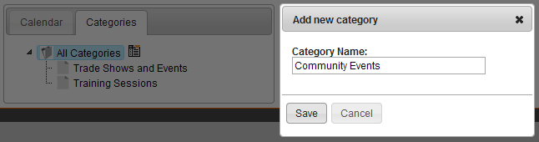

Inserting
The calendar will not be visible on the website until it is inserted into a page. To do so, go to the Content section and select or create the page that you would like to have the calendar events displayed. Once the correct page is open, select within the editor box and then select the Calendar icon from the bottom right section of the editor buttons. If you do not know which icon is the calendar, you can hover your cursor over the icon and a description will display.
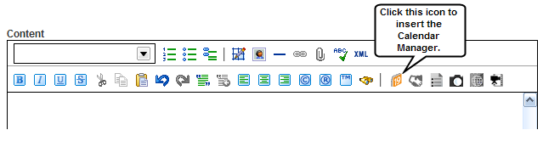
Insert Options
Once the icon has been selected, a window will open for you to select the calendar view you would like to use. Select the view you desire and if you have the Enhanced Calendar, also select the category. Read the next section titled, Views for more information about the Calendar viewing options. You can enter a title for the calendar, but it isn’t necessary. Once you have made your selections/changes, click Save and then click Publish on the page.

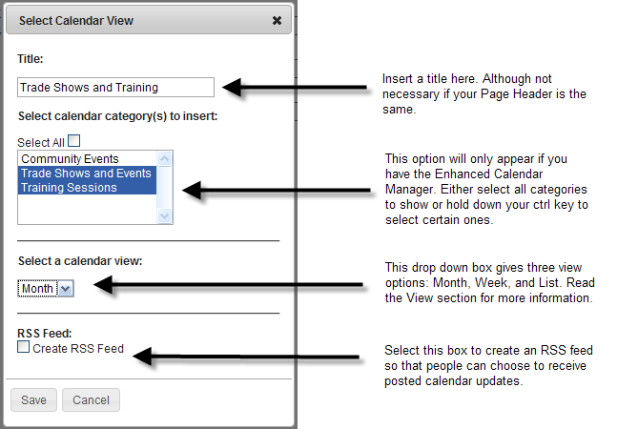

Views
The calendar module can be implemented into pages in three different views: Month, Week, and List view. The Month view is a full calendar and will take up the entire page showing in month view. The Week view is much smaller and only takes up a portion of the page, displaying one week. The list view calendar will list the events by date and event title. Each calendar view will display the current month or week reflecting the day viewed. There are also arrows before and after the month heading for people to look at past and future events. Here is an example of the display: < March 2010 >

Month View
The month view will take up the entire page and display a full month of events. A viewer can click on any event and a box will open up giving full event details as shown below. Users can upload images and links in this box for people to follow. A printable option is also available only in the Month view.

Like the example below, the month view is most helpful for things like class schedules or for events that repeat daily or weekly. The Month view can stand alone when it provides lots of information. If you don’t have several events per month, your calendar might look bare with the Month view.
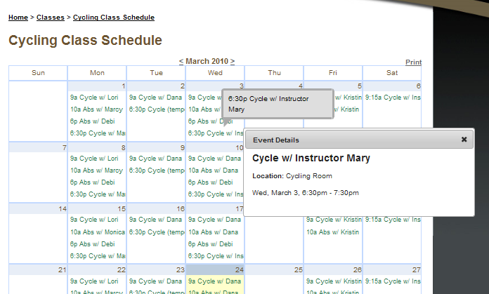

Week View
The Week view option only shows the current week’s scheduled events. Like the Month view, each event will open to show more detailed information about the event. Because the Week view takes up much less space than the month view, it is a great addition to a page, however we would not recommend using the Week view as a stand along feature.
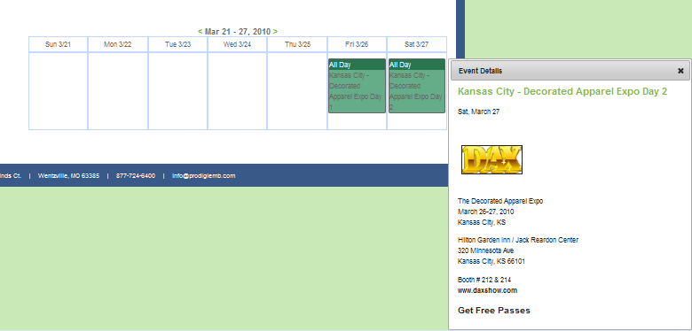

List View
The List view will list out all events in a given month. When an event is clicked on in the List view, the calendar will drop down revealing further details. If you have content below the calendar, the content will move down as the calendar moves. The benefit with the List view is that people can see several event details at once, whereas with the Month and Week view, only one event box with details can be open at a time.
