Careers Manager
Users Manual

Careers Manager
The Careers Manager empowers your Human Resources personnel to take control of this section of the website without assistance from your internal IT or web design departments. New job listings can be posted within a matter of minutes allowing HR personnel to streamline the entire online resume generation process.

Locations
Empoweren will automatically have one location for the Careers Manager, but multiple locations can be created in the Enhanced Careers Manager. With the Enhanced Careers Manager you can add and delete locations by clicking on the Locations tab while inside the Careers section. Once in the Locations section, click on New Location, enter the location name, and select Save Location.

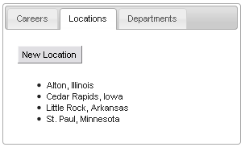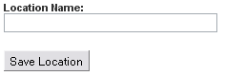

You can also update or delete an existing location, by clicking on the Location name and by following the simple directions shown below:

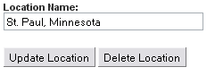

Departments
To create a new posting, at least one department must exist to house this posting. To create a new department, click on the Department tab in the Careers section, then select the New Department button. Enter the department name and click Save Department.

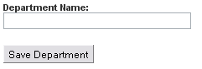

Careers
To post a new career, click on the Careers tab in the Careers section and select the New Career button. This will open up the posting information fields on the right side. Select a department and posting date, enter a position title, and enter a Job ID (if applicable).

Once you have entered a Career Posting (Job Listing), these will show below the New Career button and you can click on the existing career postings in order to edit the.

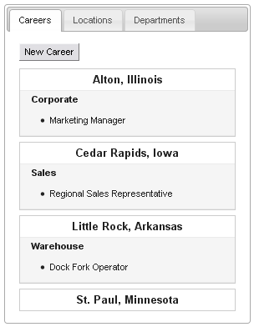

Clicking on the New Career button or clicking to edit and existing listing will bring up the following elements to be completed.

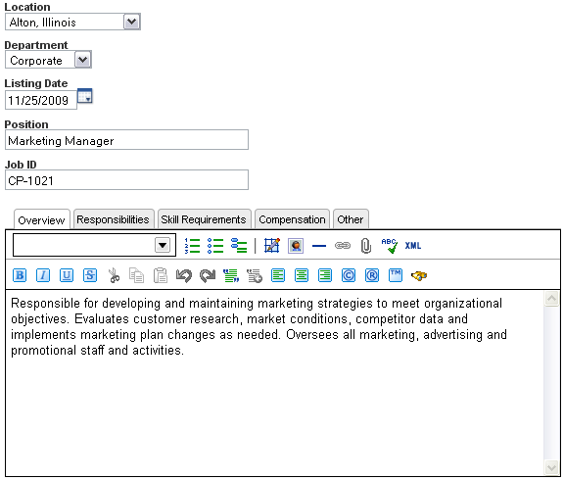

Location – Choose a location from the dropdown box that you have populated.

Department - Choose a location from the dropdown box that you have populated.

Listing Date – Chooses the date that you want Empoweren to publish the career posting on your website.

Position – Enter the title of the position. This will show up as the career name within the Careers Tab and as the headline on the individual career page.

Job ID – This space is provided should you utilize any type of job ID or job numbers to your career postings.

After these fields is a WYSIWIG application so that you can construct job listings in any manner that you want. If you wish to use the 5 headers provided, then these sub-headlines and spacing will be integrated into the career posting page.

Overview/Responsibilities/Skills/Compensation/Other Tabs
The default tab of the editor is the Overview tab. Any information entered in the editor with the Overview tab selected will appear in the Overview section. To enter information in the other tab areas, select that tab and then enter the information in the text field of the editor.

*Only the tabs with content will show on the website. If you choose to not put information in any of the editor tabs, the entire section will not show on the website.

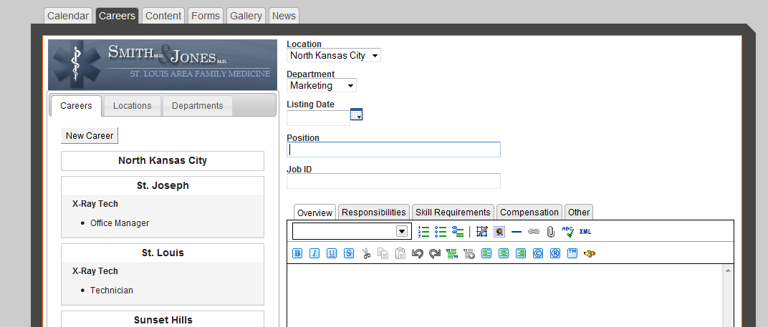

Education/Experience/Type
To enter more information about the position, select the Job Type/Education Level/Experience Level section below the editor and enter the appropriate information.

Resume Submission & Upload
This section will default to None, but you can select from the drop down the option to upload a resume. If you select this option, fields will open below for a custom thank you message and the email to send the document to.

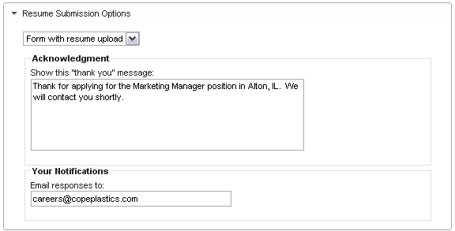

When the ‘Form with Resume Upload’ option is selected, the following form will be added at the end of the job posting with the default fields provided. Only the accepted formats will be uploaded and the file will come as an attachment to the form submission email.

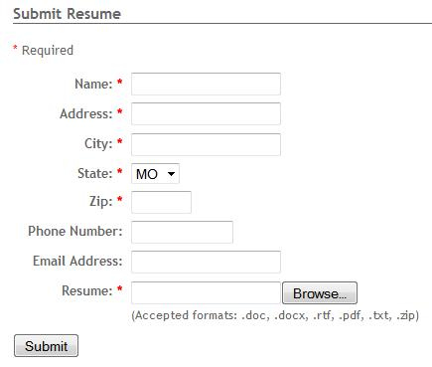

Publishing Options
The publishing options follow the same principles as outlined in the Content section. One additional feature in this module is that you can make a page active for a certain date range. This allows you to easily set a day for the job posting to come down so that you can stop taking applications for the position.

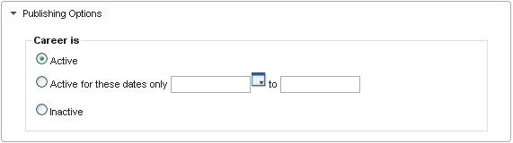

Meta Data

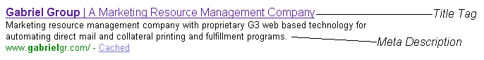

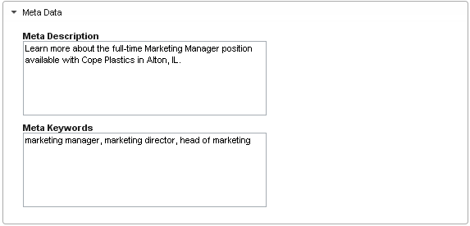

Inserting
It is only necessary to enter the careers section once on the desired page. Every position that is added after the careers section is inserted will automatically be updated on the site.

