Content Manager
Users Manual

Content Manager

The content section is the core area of the Empoweren content management system. It is typically where you will publish information about your company, products, services, locations, and the like. It utilizes a very robust WYSIWIG editor that provides you with the freedom to design individual pages as you like.

How it Works
As shown below, the left side of the admin screen within the content tab displays the navigation for the entire website. By clicking on the small arrows on the left, you can expand the folders to view all pages and the overall hierarchy of the site. The first level of pages within the Home page will appear in the main navigation of the site. The second level pages (within the first level pages) will appear in the drop downs of the main menu.

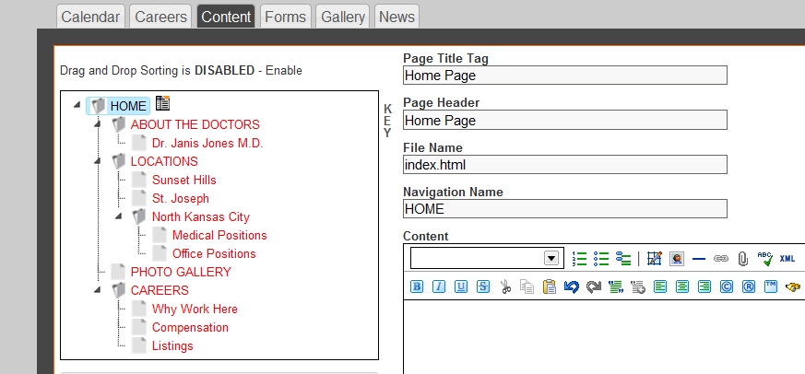

When creating a new website, it can be very helpful to map out your site’s hierarchy in a separate document. We have found that the Organization Chart options in Powerpoint can make this process relatively easy, but there are many programs that can aid you and for smaller sites, simply using pen and paper often will suffice.

SEO Tips
- Keep in mind when setting up your site hierarchy that your home page will typically have the most link popularity of any page in your site and that this attribute typically gets lower as the search engines work down to the lower level pages in your site. As such, placing important “SEO-Friendly” content too low in your site hierarchy can inhibit its ability to achieve high rankings.

- For those with large or complex sites, you may also run into User Navigation or Usability issues when it comes to how to construct your site. While many new web designers do not pay much attention to the proper application of web site usability, it is an incredibly important aspect to ensuring that visitors who come to your site will be able to find what they are looking for quickly and easily. We can recommend books by Jakob Nielsen or Steve Krug on this topic or your Empoweren Account Management team can help you with this aspect of your site.

Create a New Page
To create a new page within the site, select the area in which you would like the new page to be located, click once on the page name and then click on the menu icon to the right of that page.

For instance, if you wanted to add a new page that would link from your primary “Services” page and menu, simply click on the page named Services and the New Page Icon will appear as shown.

When you click on this icon, the following dropdown list will appear with the following options:
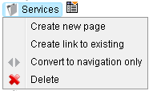

- Create New Page
This will be your most common option as it is what you click to add a new page (with new content) to the site. As shown below, you will have three options on where to place this new page relative to the page you clicked.

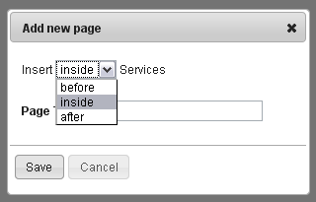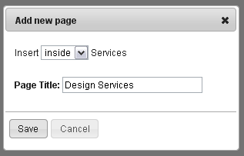

Before: While you cannot add a page before the home page, this option is available for all other pages and allows you to place a page in the site hierarchy on the same level just before the one that you clicked.

Inside: This option will add a page within the section that you clicked. For instance, a page named “Design Services” may be added within a section that highlights all “Services” offered. From a site hierarchy perspective, this would be

After: This command allows you to place a page in the site hierarchy on the same level just after the one that you clicked.

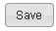 Click SAVE to add the page.

Screen shot of site with hierarchy built out and with new Design Services Page added within the Services section. As you can see, the Design Services page is indented which indicates that it is one level below the main Services page in the site hierarchy.

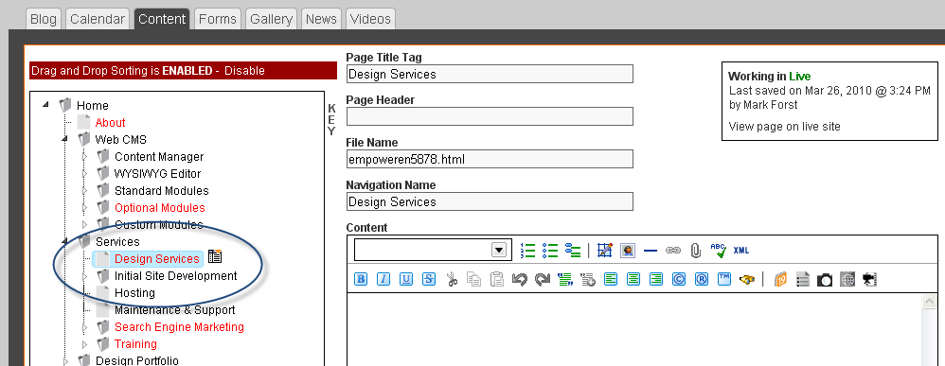

Note: The Page Title that you choose will become the Page Title and the Navigation Name, but these can be changed at any time.

SEO/User Navigation Tips
It is typically recommended that Navigation Names be short, yet very descriptive. You want the visitor clicking on this link to understand what the page is going to be about that they are going to. Furthermore, user navigation specialists advise using Headers (or page headlines) that match the Navigation Name very closely so that site visitors do not get confused about where they are in the site once they click on a link.

It is also important to note one factor in how well a web page complies to search engine ranking algorithms is the “inbound link text” to this page. In this case, the “inbound link text” is the Navigation Name.

In our simple example above, a page named Brass Widgets would logically contain content about a company’s line of Brass Widgets. If one was trying to rank well for this search phrase in the general search engines, using the navigation name “Brass Widgets” and Page Header of “Brass Widgets” would help it comply with the ranking algorithm for that particular phrase.

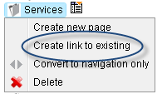
- Create Link to Existing
This option exists for those instances when you want to add the same page to multiple areas of your site. The example below should help explain this concept.

Suppose you are building a site that sells office furniture. Among your many products, you sell Brand X’s line of ergonomic office chairs. You have already created a page for Brand X’s “Exhilarating” office chair and placed it within the Ergonomic Office Chairs section of your site.

You now want to link to this page, but from a new section of your site where you are going to list all of the Brand X products that you offer. To do this, you would click on the “Create Link to Existing” option in the dropdown menu for the Brand X page.

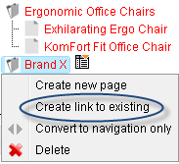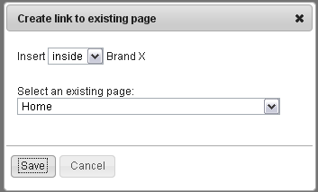

Click on the arrow and it will bring up a list of all pages in the site. Choose the page that you want to link.

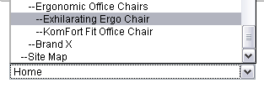

You will then see the page added to the Brand X section with a link sign in front of it as shown below. The Exhilarating Ergo Chair page now resides within two sections of the site.

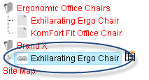
- Convert to Navigation Only

For pages which contain sub-pages, clicking on these page titles will bring up an option named “Convert to navigation only” as shown here.

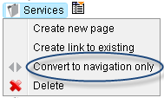

This option exists in case you want to create a sectional headline in your navigation, but you don’t necessarily want to create a page with content on it.

Say, for instance, you want to have a section called Company in your global (primary) navigation, but you don’t necessarily need any content on this page as this section only has three sub-pages as shown here.

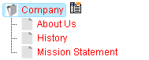

Click on Company and choose “Convert to navigation only” from the dropdown box. This will bring up the following screen where you can confirm.

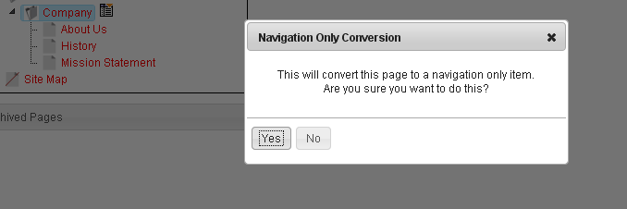

It will then show up in the site navigation with next to the Navigation Name so that you can tell that this page exists ONLY in the navigation as shown below.

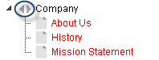

Once a page is set up as Navigation Only, you can convert it back to a standard content page by opening its dropdown menu and clicking on the “Convert from navigation” option.

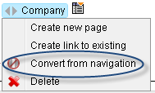
- Delete
Clicking on this item will prompt a message confirming that you want to delete the page.

If you are trying to delete a page that has subpages, you will be prompted (as shown below) to choose between deleting all the subpages as well or just the page selected.

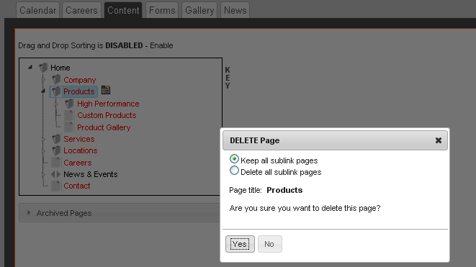

Archived Pages

If you realize that you shouldn’t have deleted a page, you can find all deleted pages in the Archived Pages section linked from a tab bar located just below the site structure box.

Open the dropdown menu and select a page.

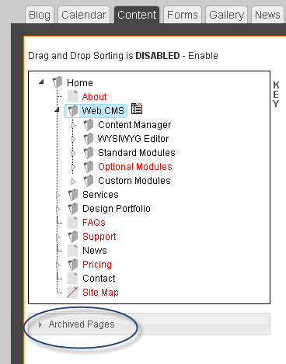

It will open up a window to show you the content of the deleted page. You then have the option to close the window or restore the page to the site navigation.

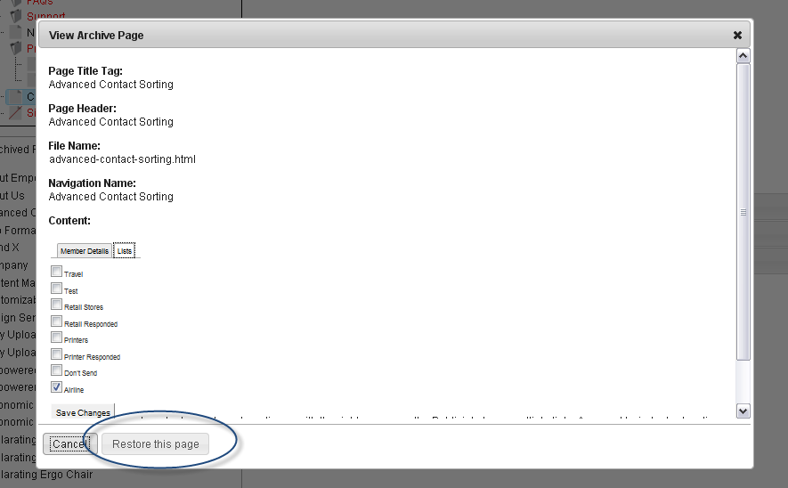
Moving Pages Using the Drag & Drop Feature
Once you have added a number of pages to your site, the drag and drop feature will allow you to easily rearrange the order of the pages as well as promote or demote pages to different levels.

Enabling the Drag & Drop Feature
To use the drag and drop feature, select Enable directly above the navigation box. This will refresh the page and the bar above the navigation will be RED as shown below.

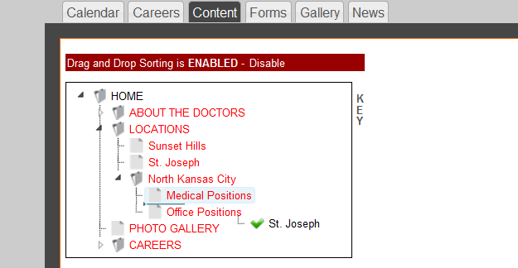

To move a page, simply click on the page and drag it to the desired location. You will see a grey line indicating where the page will be dropped and a green checkmark will show if the location is acceptable. If the page cannot be moved to a certain location, a red X will appear next to the name of the page.

To promote or demote a page, drag it into a different folder in the navigation. This will make the page a higher or lower level in the hierarchy. Be sure to pay attention to the pages that are in the main menu (global navigation), as these can be modified as well and this may throw off the layout of the global header used throughout the site.

Adding Page Elements
While you will use the WYSIWIG editor to design most aspects of your web pages, Empoweren’s Content Manager is set up so that you can also easily control the Navigation and SEO (search engine optimization) elements of a page.

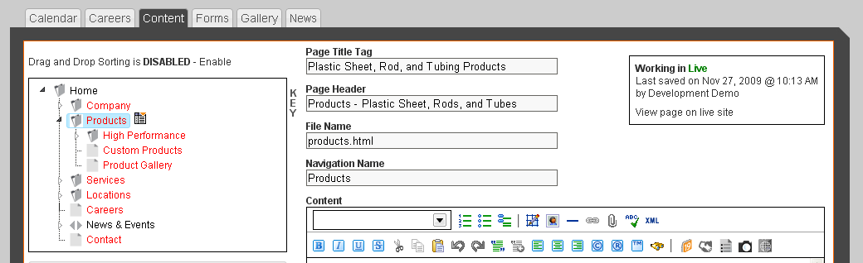

Page Title Tag
The title tag is the text that appears in the top bar of your browser window and what essentially serves as your primary advertising line in the organic listings of most search engines. Here is an example of an organic listing in Google.

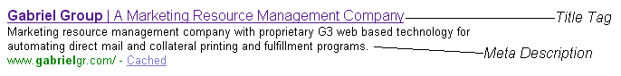

Not only is the Title Tag important because it provides the user with information about the page they are on or going to visit, but it is typically the most valuable factor in determining high search engine rankings. As such, it is best to use keywords that are relevant to the content on each particular page.

Because most search engines limit the number of characters that they will display, it is typically recommended that you limit the Page Title Tag to 65 characters including spaces. As a default setting, all page title tags in Empoweren will automatically contain “Your Company Name |” and then the text you enter in the box will appear after that.

SEO Tips
- Include your target keyword phrases in your Title Tag as they relate to the page’s content
- Don’t use the same Title Tag on every page
- Try to limit to 65 characters
- Try to create a powerful message that will motivate people to click on it
- Include geographic target terms if relevant
- Utilize longer keyword phrases to have a better chance of achieving high organic rankings
- Keep in mind that if someone bookmarks your page, the title tag is what typically shows up in their bookmarks

Page Header (Page Headline)
As the name implies, the Page Header or Page Headline is the text that appears above all of the content on each page. The graphic style of the page header will be set for the entire website and will automatically appear consistent with other pages. If there are certain pages that you do not want to have a page header, you can leave the field blank and no header will appear.

From a User Navigation perspective, this header should closely match the text used in the links to get to this page in order to minimize confusion.

SEO & Usability Tips
- The Page Header is very important to earning high organic rankings so it is ideal if the target keyword phrases for this page can be integrated into it.
- Headlines should closely match the text used in the inbound links to this page so as not to confuse users navigating through your site.

File Name
The file name is the extension of the page URL (i.e. http://www.yourdomain.com/file-name.html). The file name field will automatically put dashes in between the words and .html at the end so that it is formatted properly. It is best to make the file name similar to the page header and descriptive of the page content.

SEO & Usability Tips
- Include keywords in file names to help SEO.

Navigation Name
The navigation name is how the page will appear in the navigation of the website (typically the left hand column on a page that provides links to all of the pages within a section.

When new pages are created, make sure that the navigation name is clear and cohesive with the content of the page and try to incorporate keywords for SEO purposes where possible.

Content
Instructions on how to enter information, links, charts, images, and other elements in the content section are documented in the WYSIWIG Users Manual.
Meta Data/Redirects
This is the section that controls other features for each individual page that are related to search engine optimization.

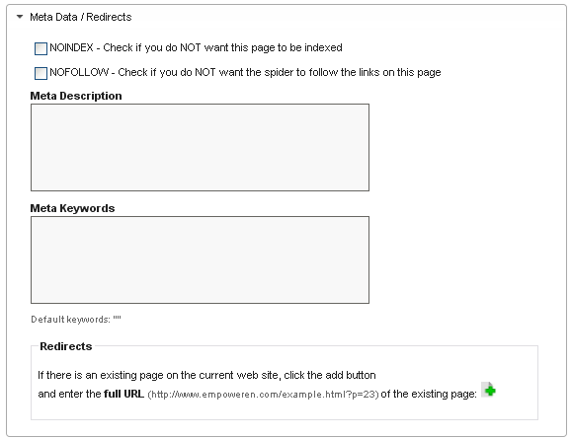

NO INDEX – If you do not want to the search engines to index a particular page, click this box. This means that if someone searches for something related to your page content, your page will not be included in the search engine results.

It is often used when you are publishing information that you wish to keep slightly more private, for landing pages specific to certain CPC or banner campaigns, or to prioritize a certain page when multiple pages all contain essentially the same information.

NO FOLLOW – According to many sources, the Nofollow attribute was originally designed to stop SEP spammers from commenting on blogs and forums. If you do not want the search engines to follow the links on a particular page, click this box. The links will still work properly if this is selected, but the search engines will not be able to go to the pages that the links point to.

No Follow attributes can be helpful if you want to link to other sites, but not pass link popularity to them.

Meta Description
This is the small amount of text below the page title that appears in search engine results as shown here.

It is important to include keywords related to the content on each individual page and also write compelling copy that will explain what you offer and let the user know that the page will contain the information/products they are looking for. To prevent the description from being cut off in the search engine results, it is suggested that it be no more than 165 characters.

SEO Tips
- Try to incorporate your keywords or synonyms of your keywords. If you are targeting a three or four word phrase, we sometimes recommend using plurals, changing the word order, or using synonyms so as not to trip an over optimization filter.
- Be creative and try to use the Meta Description to entice people to click.

Meta Keywords
This is a collection of keywords that are related to the content on each page. The search engines read the list keywords, but they are not displayed on the website or in the search engine results.

In the early days of search engines, Meta Keywords played a role in the search engine rankings, but their value has diminished over time and currently offer little to no help in achieving high rankings.

They can however, remain very helpful for an internal search engine. Suppose, for instance, that your site sold a line of books tailored to 1st graders. Since you want people to find this page for searches like Grade 1 Books, Grade One Books, First Grade Books, Books for First Grader, First Grade Literature you would want to enter the Meta Keywords:

1st, first, grade, one, 1, grader, graders, book, books, literature

As well as any other relevant words in the copy like: Math, teaching, popular, reading, online, chapter, math

Redirects
The redirects section is extremely important if you have a page from a previous website that has been replaced by a new page (with similar content) on this new website and the file names are different.

Conceptually, re-directs are similar to telling the post office your new address if you move homes.

By entering the URL from the old page, the search engines will see that the old page is now located at a new URL and you will minimize the danger of losing search engine rankings that often accompanies site re-designs.

To create a new redirect, click on the green plus sign and enter the entire URL in the box. Existing redirects can be deleted by clicking on the red minus sign.

If you can name your new pages with the exact same file names as the old site, this can work even better, but it is not always possible due to the use of different file name extensions.

Publishing Options
This section allows you to determine whether or not a page is active, active for a specific time period, or inactive.

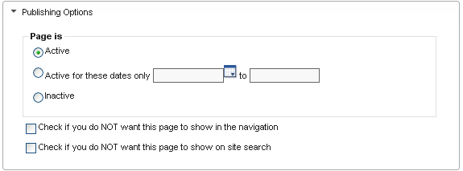

Active
An Active page is one that is or will be live on the published website.

Active for these dates only
If the page is for an event like a sale or your attendance at a trade show, you can set the page to be active for certain dates by using the “Active for these dates only” boxes.

Inactive
If a page is marked inactive, it will not be published on the live site. All of the content, however, will be preserved and the page will still appear in the admin, only with an X on the name of the page.

Revision History
This feature will allow you to see all of the past revisions that have been made to each individual page, along with the date, time, and user. By selecting a specific revision, the page details will open in a new window and you will have the option to revert to that version of the page if preferred. This is helpful in case information is deleted or a new page design isn’t getting as good of results as a previous version.

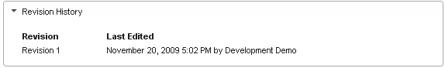

Save & Publish

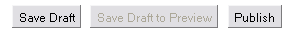

Save Draft
The Save Draft button at the bottom of each page will allow you to save the page you are working on as a draft, which means that it will not be visible on the live website and can be further modified or published at a later date.

Save Draft to Preview
If you would like to know what your draft version will look like when it is live, you can save the page as a draft and the “Save Draft to Preview” will change to “Preview”. If you select the Preview button, it will open the draft in a new page so that you can see what it will look like when it is live. This is an excellent feature to work out all of the kinks before the site is live for anyone to see.

Publish
The Publish button at the bottom of each page will make the changes made take effect on the live website. Any time a change is made, the Publish button will need to be clicked to complete the process.

Create Auto Generated Site Map

Creating a site map with Empoweren is as simple as creating a page with the file name "site-map" and hitting "Publish." The software creates the site map and then automatically updates as new pages are added to the database. The Site Map page can be added to the site's primary navigation although many sites simply have it linked from a static link in the site's footer.

