Forms Manager
Users Manual

Forms
Inquiry forms will help convert your website from an online brochure into a true lead generation vehicle. They represent one of the most measurable “calls to action” that one can take when visiting a site that does not employ e-Commerce functionality. Since, most analytics programs can easily track when one completes an online inquiry form, we often use these completed inquiries to help measure conversion rates and provide some return on investment data.

New Form
To create a new form, select the Forms tab and once in the Forms section, select the Create New Form button on the left. This will open a window for you to enter a Form title. Enter the name of the form and click Save. The new form page will display and the form title and Submit button will be on the right. If you do not wish for the title of the form to be displayed on the page, click once on the title box and then on the left, uncheck the Show Form Title box. To delete the form, click on the red X on the title.

Add Elements
To add elements to your form, click on the Available Elements tab to display the menu of items that can be added to the form. Click once on the desired element and it will be added to the bottom of form.

Edit Elements
To edit an element, click within the orange box around the added element and the editing panel will appear on the left side of the screen. You will be able to change field names, add/remove/name buttons, determine size of boxes, and make certain fields required.

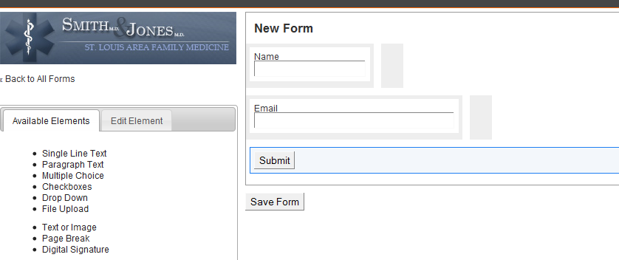

View Entries
When on the All Forms page, selecting the title of the form will open up additional options. To view the entries that users have made on the website using the form you selected, click on View Entries. This will take you to a page where the entries are listed on the left. To view the details, select the linked date/time. To export the list of entries, click on .csv for Excel or PDF.
Need an image of the viewed entries.

This data is excellent for tracking sales inquiries and monitoring the effectiveness of one’s online marketing. It has also served as an effective backup for clients who have had problems with their internal mail servers or CRM systems.

Edit Form
When on the All Forms page, selecting the title of the form will open up additional options. To edit the form, click on Edit Form. This will take you to the page where the form was created and any field can be edited by clicking in the orange surrounding box and using the editing features on the left.

Email Response/Thank You Message
When on the All Forms page, selecting the title of the form will open up additional options. To enter/change the email address that the form entries are sent, click on Email. This will allow you to enter a custom thank you message that the user will see when they complete form. Enter the email address that you would like the entries to be sent to and if you have multiple emails, they can all be entered in the same box separated by commas.

Submit Drawings, RFPs, etc
If you would like to provide the user with the ability to upload drawings, specs, RFPs, or any other documents, the File Upload element located in the Available Elements section of the form creation will allow the user to do so. It will provide a box with a “Browse” button that will allow the user to select the file from their computer and upload it to the form.

Active/Inactive
When on the All Forms page, selecting the title of the form will open up additional options. You can see whether or not a form is currently active and change it by clicking on the Enable or Disable This Form link.

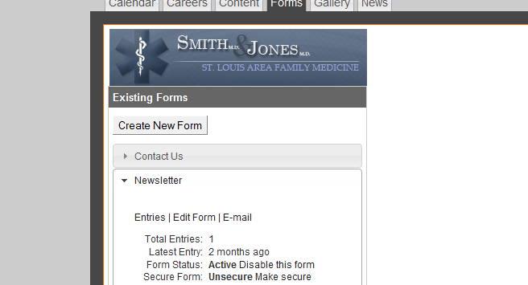

Inserting
The form will not be visible on the website until it is inserted into a page. To do so, go to the Content section and select or create the page that you would like to have the form displayed. Once the correct page is open, select within the editor box and then select the Forms icon from the bottom right section of the editor buttons. If you do not know which icon is the form, you can hover your cursor over the icon and a description will display.

Once the icon has been selected, a window will open for you to select the form you would like to insert. Once you have made your selections, click Save and then click Publish on the page.

Helpful Tips
- If you sell outside of the United States, make sure to include a field for Country and use Zip/Postal Code and State/Province for any contact information needs as these are more user friendly to a global clientele.

