Members Manager Module
When the Members Manager is activated on your Empoweren website, you will have the ability to create pages within a section that can only be accessed by authorized users. There are two ways that the Members Manager can be set up on your website, which are both described below:

- Password Protected (Single User)
The single user option eliminates the registration features and provides one username and password for all users. This is good for simple content protection or intranet items like company policies, employee schedules, etc. or for things such as dealer pricing, sales staff resources and investor information.

This option gives you full control over the content that is password protected and simplifies the member login process.

- User Registration (Multiple Users)
The multi-user option allows your website visitors to create their own specific profile and login information. This is good for knowing who is downloading your white papers or product specs, providing dealers/regions individual pricing, building your email lists/followers, etc.

This option gives you full control over the content that is exclusive to members and allows you to manage specific user profiles in Empoweren.

Setting Up the Members Content
Once the Members Manager is activated on your Empoweren site, you will need to designate the content that you would like to be available within the members area. After you log in, select the Content tab. This will bring up all of the pages that are currently a part of your site.

By right clicking on a specific page in the left hand menu, you will have the ability to select “Create Members Area” from the list of options. This will make this page the main page that members see when they log in and all pages within this section will be a part of the members area as well.

If you have content that is not currently on the site that you want to use to make a members area, you will need to create a new page, create a members area from this page, and then add all of your members content as pages within the new members page.

Changes to the Members Content
Once the members area has been created, you can make changes and updates to the content the same way you edit regular content and the changes will update immediate. This can include text, calendars, photos, forms, etc.

Registration
In the multi-user option, website visitors will have the option to register for the members area and create their own profile. They will be required to enter their first and last name and create a unique username. If the username they select is already in use, they will be prompted to make a new one. The user will also have to create and confirm an account password and then enter their email address twice. The double entry of email and password helps prevent human error to make sure the activation works smoothly.

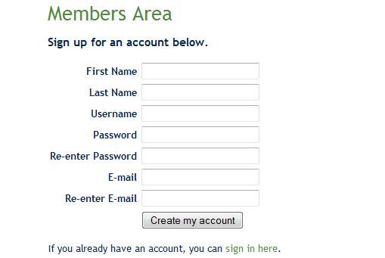

Already a Member?
If an existing member arrives at the registration page, there is a link at the bottom that will allow them to go directly to the Member Login page to sign in. This helps users to not be confused if they reach the registration page by accident.

Email Confirmation
When a user successfully completes their registration, a page will display notifying the user that they were sent an email and they need to confirm their email address and activate their account. The content of this page can be modified to fit your needs, but it is recommended that this page contain information to help guide the user through the process.

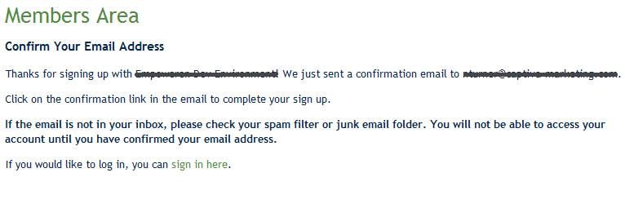

Confirmation Complete
When the user clicks the link in the activation email they received, they will be taken to a page on your website information them that the account has been activated and provides a link for them to log in with their new username and password. This page content can also be modified to meet your specific needs.

Member Log In
Once the user has confirmed their email address to validate their account, they will be able to log in with their new username and password.

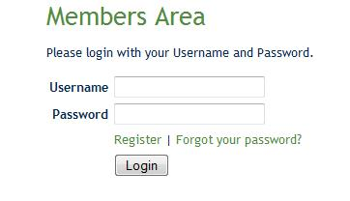

Forgot Your Password?
If the user cannot remember their password, or their password isn’t working, they can click the “Forgot your password?” link. This will require the user to enter the email address on the account and submit. This will email the user a new password, not their existing password, and they will then be able to log in with their username and new password.

My Account
Once the user has logged in to their account, they have the ability to edit some of their personal information in the My Account section.

Logout
Any time the user wishes to log out of the members area, they can click Logout, which is located at the top of the content section, next to My Account.

Managing Members
When you have logged into Empoweren, you will be able to monitor and manage your members by clicking on the Members tab. This will give you a general overview of your Active, Waiting on Activation, and Deleted members.

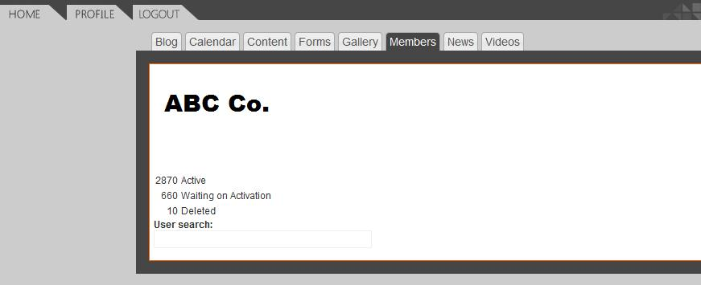

Locating a Specific Member
Within the members manager, you have the ability to search for members, which can find members by their name, email address or username. This is an easy way for you to quickly find a profile if a specific member needs help with their profile.

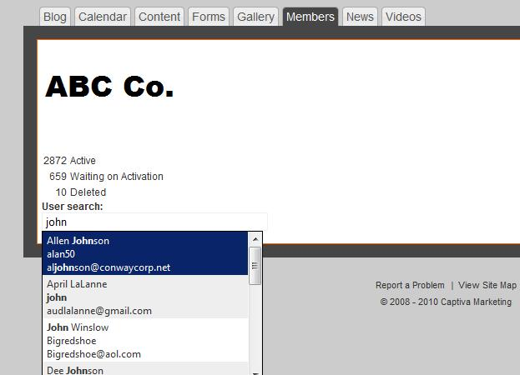

Viewing Lists of Members
From the members manager overview page, you can click on a specific list (i.e. Active) to view all of the profiles within this list.

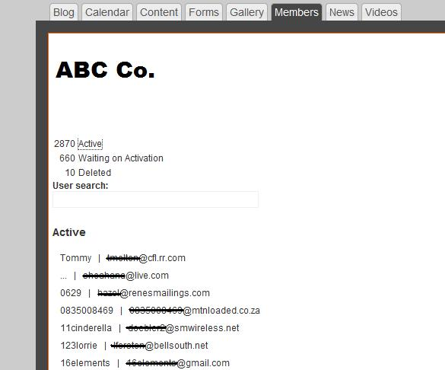

Viewing a Specific Member Profile
While looking at a specific list, you can also look at a specific member profile by clicking on the username. This will open up the member’s profile to show you their information and allow you to reset their password or delete their profile.

Resetting a Member’s Password
After you located a specific activated member’s profile, there will be a button to reset their password. If you reset their password, this will email the member a randomly generated password, the same as when the user submits for a forgotten password. Once the member has logged in with the new password, they can change their password to something easy for them to remember in the My Account section. If the member has not yet activated their account, they will need to do so prior to logging in, as resetting the password will not work.

Resending Activation Emails
If a user registers for an account but does not activate their account, they will not be able to log in and they will be listed in the Waiting on Activation section of the members manager. If a user needs the activation email to be resent, you can locate their profile in the Waiting on Activation list, or by searching, and there will be a button to resend the activation email.

“I’m not receiving an activation email”
Depending on the user’s email settings, the activation email could be listed as spam or junk email. The email is sent from no-reply@empoweren.com, so that is what the user should look for.

“I can’t click on the link in the email”
If the user cannot click on the link in the email, this is because of their personal email settings. They can copy the link and paste it in their browser and it should work the same way.

