News Manager & Publicist
Users Manual

News Manager
Adding News Stories to your site is one of the easiest keep in contact with customers, employees, prospects, members, investors, residents, or anyone else that visits your site. It is also one of the most effective ways to add search engine friendly content to your site without having to worry about how to intelligently integrate it into your site navigation.

Categories
Before creating a new article, you will need to create a category. To do so, click on the Categories tab within the News section. Click once on All Categories and then click on the menu icon and select New Category inside this. A window will pop up and you will need to enter the name of the category and click Save.

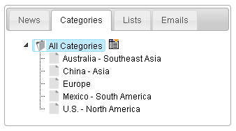

In many cases, simply having a single News page will suffice, but many clients have chosen to break out their news managers into categories like this:

- Geographically (as shown above)
- In the News
- Press Releases
- New Products
- Community
- People
- Employee News

New Article
Once a category has been created, click on the News tab and click Create New Article. This will open up the article on the right side with all of the information fields. First, select the category and the publication date of the article. The following sections (Page Title, Headline, and File Name) are all the same as the website page in the Content section.

The final file name will add the publication date to the front of the file name you created so the system knows to pull an article, rather than a page with the same file name. The short description is a 2-3 sentence ‘lead-in’ that will display under the title of the article on the news page. The content of the article should be included in the main section of the editor.

The Meta Data and Redirects are the same as in the Content section. (Link or page number)

The Publishing Options section is important because it has different features than regular content pages. You can select a specific date and time to publish the article down to the minute. Also, if your site has a homepage has a news section or a news feed, you can select whether or not to syndicate each specific article them.

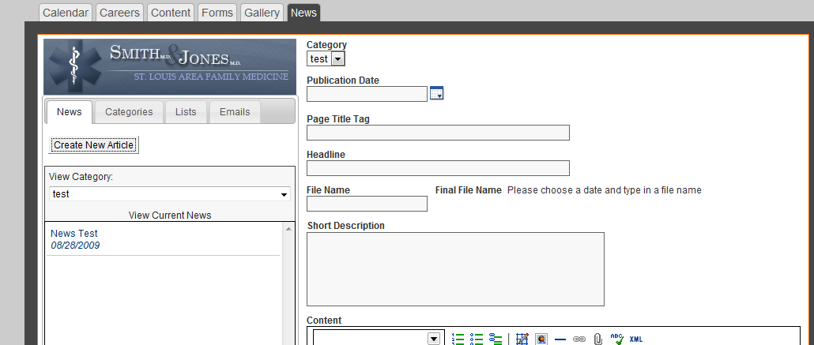

News Manager with Publicist
The Publicist Module of the News manager is designed to streamline the press release distribution process. With it, you can enter the contact information for journalists, writers, and editors that may be interested in your news and then quickly email press releases to them.

Newsroom Set Up

The newsroom module of empoweren allows your company to publish company news in different categories. As newsroom is a great place to add new copy to your site on a regular basis and also tells your audience how your company is growing and improving.

Some quick info about newsrooms:
- Online newsrooms create a one-stop-shop for journalists to gain all the information necessary to write a story about your company.
- The TEK International 2007 Journalist Survey found that half of all journalists use online newsrooms at least once a week and that more than 85% use them every month. (This number has grown in the years since this survey was commissioned.)
- Additionally, your audience uses your online newsroom to stay in tune with new happenings within your organization.

Updating news in the Empoweren News Manager is extremely similar to updating content pages in the content manager.

Adding Categories

The first thing you need to do when setting up a newsroom for your website is to add a category for your news. Sometimes this will already be set up when you first login to Empoweren but it is different depending on your site.

To add a category, click into the category tab in the news manager as shown below. You will be prompted to add a category initially if there isn’t one already set up. If you need to add an additional category, click on the tab next to a category and select the appropriate new category option.

Note: Most sites are set up with one category as the default. If you want multiple categories in the navigation, please contact your account manager because that will need to be added to the design of your site.

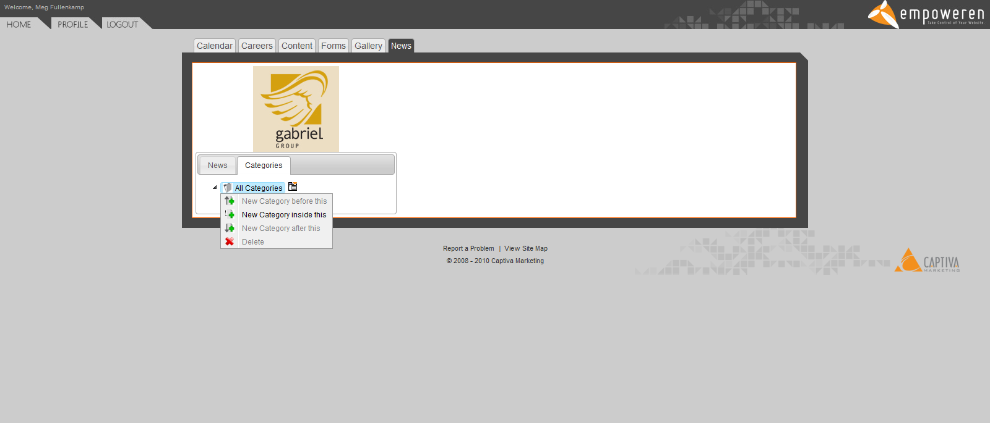

Creating a New Article

To create a new article, leave the category tab by clicking on the news tab. Click on the “create new article” button.

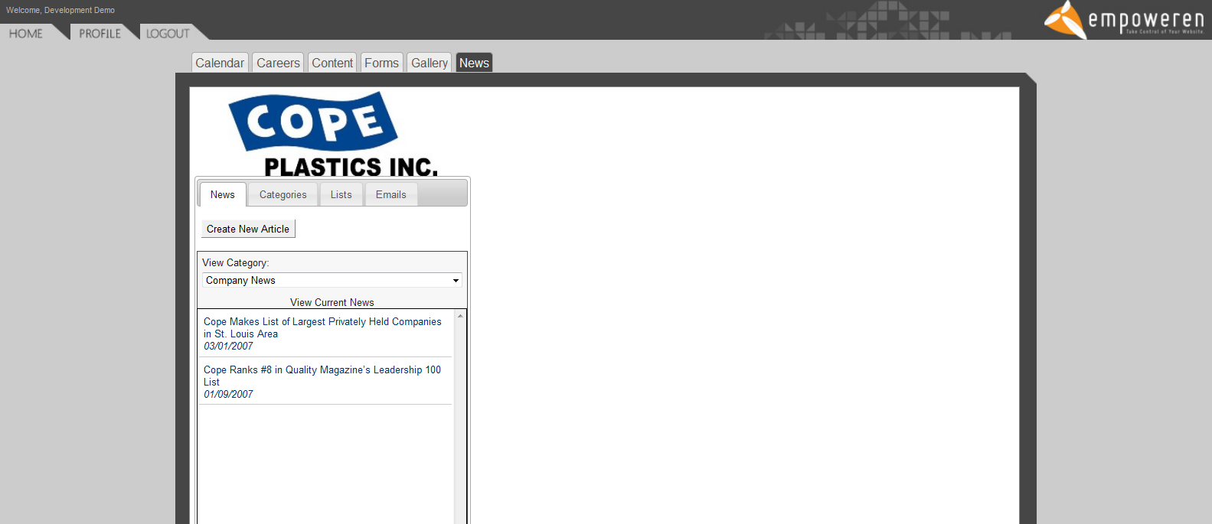

You will then be taken to a new page where you will build the new article. Many of the individual elements are extremely similar to the content manager but here is a brief overview of everything.

Category: In this drop down menu, you can select which news category this article should belong in.

Publication Date: This date doesn’t necessarily need to be the date that you are updating the newsroom. It needs to be the date which appears on the press release. Many clients back fill their newsrooms with old articles, so feel free to use dates in the past. Articles are organized in your newsroom by date, so keep this in mind when selecting publication dates. The most recent article always appears on the top.

Page Title Tag: As with the content manager, this is the name of the page that appears at the top of a browser window. It also appears often as the headline in search results. Title tags default to Your Company Name | and then any text that you add. Often your title tag can be almost the exact same thing as your article headline.

Headline: The headline is the headline of the press release. It will appear on the news summary page to direct people to your article and at the top of that article’s individual page. Ideally an optimized headline includes your company name and a keyword phrase within the first 60 characters.

File Name: This will determine the URL of this page on your website. Many times the URL can be a shortened version of the headline. Empoweren will automatically add underscores and a date to complete the URL.

Short Description: This is a brief summary paragraph about the release. The short description is a good place to fit in keywords that didn’t get into the headline or different variations on keywords. Depending on how your main news page is set up, this description will show up as a summary below each press release headline. The short description also is often the summary paragraph that is pulled in search engine results so try to keep the important information to the front. Descriptions should not be more than three average length sentences.

Content: This is the section where the body of your release should be entered. You do not need to reenter the headline in this space. The content section uses the same WYSIWYG editor that is used within the content manager. Many times you can just copy and paste your entire press release (minus the headline) directly into this box.

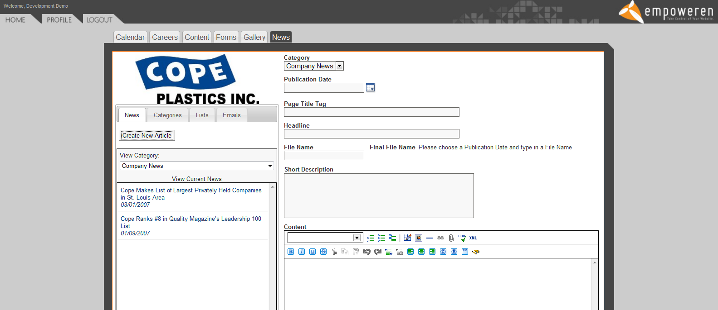

Meta Data/Redirects
This accordion menu contains many of the SEO elements of the page.

Meta Description: Empoweren is designed to automatically pull your short description into the meta data box as well. So most times you will not need to worry about this box since it will already have content.

Meta Keywords: This box is where you should put your company keywords. Also try to add some keywords that are related to the content of the press release.

Redirects: If you are adding an article that was previously on your old website, you need to enter the old URL in this section so that a redirect is automatically created. This way anyone who had the previous link will still be able to get to this page. To add a redirect, click on the green plus sign and add the old URL in the space provided.

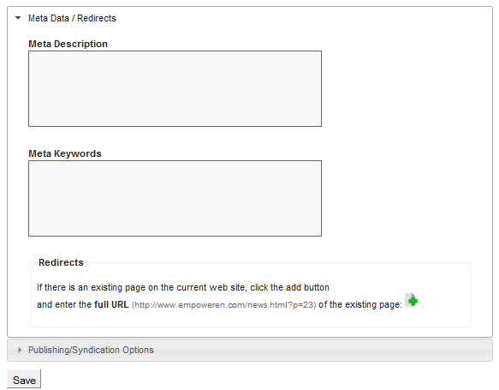

Publishing/Syndication Options
The news manager gives you three options for how to publish your article.

Publish: This option publishes the article to your website immediately.

Publish On: This option allows you to set an exact date and time in the future for when your news goes live. This is especially important for time sensitive news because you can add the article in the system ahead of time and schedule it to go live at a certain date/time.

Unpublish: If for any reason you want to take an article off your site, you can hit unpublish. This is better than deleting the article because it can be added back to the site at any time or can be archived in your records. If for some reason you want an article in your back end but don’t want it live, this is the best solution. Sometimes, when using the publicist system in conjunction with the news manager, you will want to unpublish and article so that you can use the system to send an article to the media first before it goes live on your site.

Syndication: Some sites have a news feed on the home page. If your site has this option, check this box if you want to add this release to the home page.

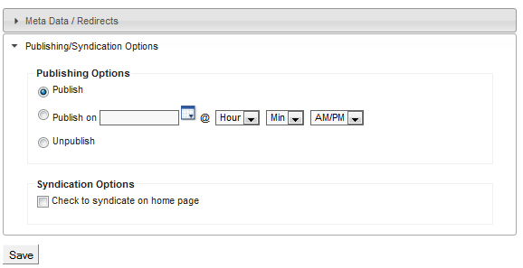

The save button is at the bottom of the page. You can select save at any time while editing the article without disturbing your progress. After you save your article, another button will appear to allow you to delete the article. Only do this if you do not want the article to remain in the back end of the site. We recommend that you unpublish your articles instead of deleting them if possible.

Using Media Lists

The publicist system allows you to store media contacts in the Empoweren system so that you can automate some of the more mundane tasks in PR such as emailing each contact individually. Captiva can help with some of the set up of this part of the system, including using our access to the Cision media database to create targeted media lists that will allow you to contact key editors that are most likely to write about your company and its products/services.

When you click into the “lists” tab in the publicist system, you will see an overview of the lists stored in your system and how many members are in each of these lists.

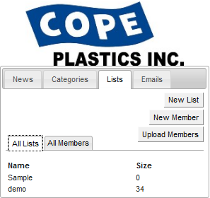

You can access any of these lists individually by clicking on the name of the list itself. Or you can see all the contacts stored in your system by clicking on the “all members” tab.

Adding New Lists
Captiva will load media contacts into the system, however, if you would like to add new members to your lists, it is fairly simple. If you need to create a whole new list, click on the new list button. A popup box will prompt you to name your list. We recommend naming your list by industry and or media type. So example names could include “St. Louis Local” or “Plastic Manufacturing Pubs.” This will help you determine which list to use when you are sending out press releases.

Adding New Members
If you just need to add one member to your list, choose the new member button. You will be directed to a new member form. You can any information about that member of the media on this form. However, the only field that is required is the email address field. We recommend at least filling out email address, first name, last name and outlet name (name of the publication, broadcast station, blog, website, etc.)

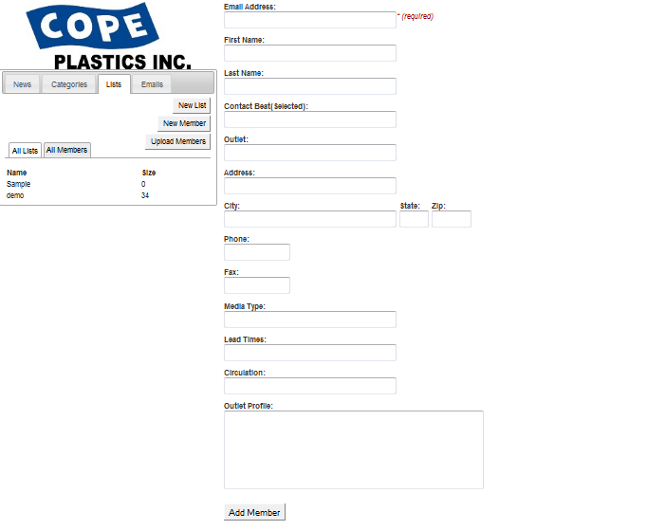

Once you have added a member, if you go back to that person there will be a new list tab in that member’s profile. To add someone to a specific list, click into this tab. You can then select any existing list and hit save changes to add that member to that list. You can also use this space to take people off of lists or to add someone to multiple lists.

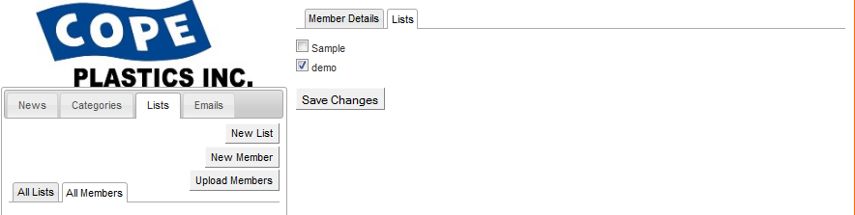

Uploading Lists
For the most part, we can take care of uploading media lists, but if you have an existing media list or contact list that you want to upload to the system, it needs to be formatted in a very specific way. The files need to be saved in .csv format, and the fields need to be exactly in this order. Only the email address is required, but at least first name and outlet name are also recommended.

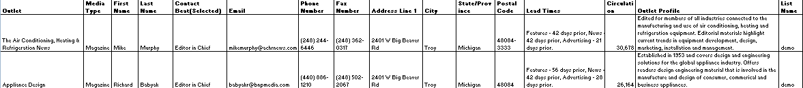

- Outlet Name
- Media Type (i.e. blog, magazine, website, tv station, etc)
- First Name
- Last Name
- Contact Beat (i.e. managing editor)
- Email Address*
- Phone Number
- Fax Number
- Address
- City
- State/Province
- Postal Code
- Lead time
- Circulation
- Outlet Profile
- List Name**

*only required field but must be in field F when uploading a .csv file
** if you fill out field P, it will automatically sort that contact into that list. Make sure it is exactly the same as an existing list or that it is a new list name.

To upload a list that is formatted in this manner, just click on the “upload members” button and you will be prompted to find the list file in your computer and then it will automatically upload.

Using Lists
After you click on the list itself on the “all members” tab, a spread sheet will open that lists the members in that list. The default is that members are sorted by outlet name, but by clicking on the headings in the spread sheet such as last name or email address will resort the list based on that field.

On the bottom of the spreadsheet there are additional sorting options. The system defaults to only show 50 rows of members at one time, you can increase this number by selection 100 or 200 from the drop down menu. Or you can scroll through the pages using the arrow keys.

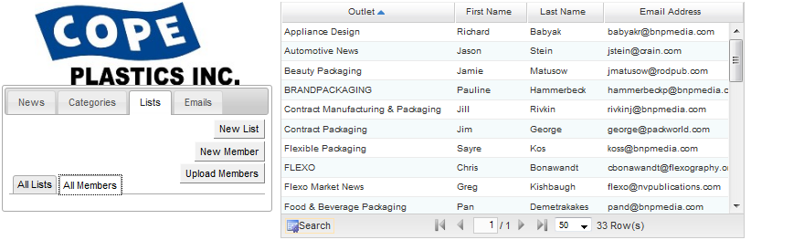

Depending on the number of industries your company is in or the types of media lists that you use, it may be easiest to find a certain member by searching for them. To do so click on the search button underneath the spreadsheet.

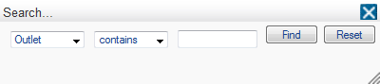

After you select search, a popup menu will allow you to search an outlet, last name, first name or email address. Just type your query in the third box and hit “find.”

Once you have selected a member in a list, you can edit any of the details directly in that person’s bio. Just make sure you save the contact information after you make any changes by clicking the update member selection.

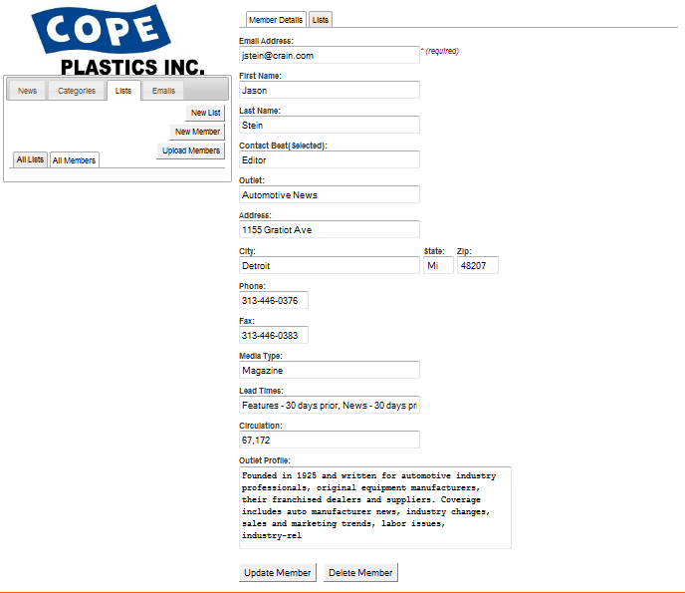

Emails
Sending press releases out to reporters in emails is the main function of the Publicist. It streamlines some of the more time intensive aspects of pitching and allows you to quickly get your story in front of the key journalists in your industry.

Creating a new email:
To start a new email, in the “emails” tab, click on the “new email” button. You will then be directed to the email template page.

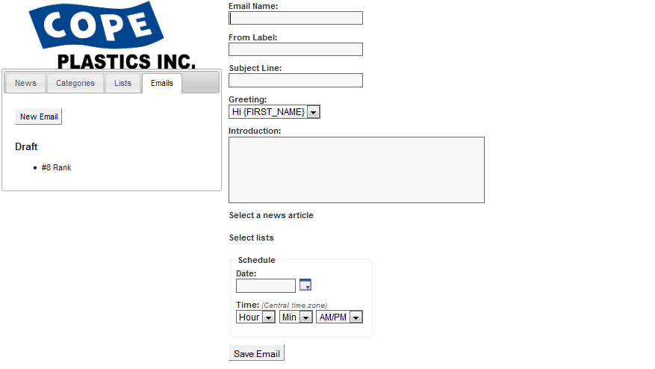

Here are descriptions for the main fields that need to be completed in this section.

Email Name: This name is for internal uses only. We recommend naming the email with the subject and the intended audience in it so it is easy to track, i.e. “Office Expansion Release-Industrial”.

From Label: This can either be the individual that is sending out the release or the company name. We typically recommend using the name of the person who is in charge of setting up media interviews and coordinates the PR process. The publicist routes these emails through a third party server so this field is what shows up in the “from” section of an email.

Note: We set up a default email address that receives all replies from this email. So you will specify where this email needs to go. Then email will come from “Your Name [your_name@mail.vresp.com]” when it is received. All replies will go to the email address specified during the set up process. The From Label only specifies the name that is outside of the email address in the from field.

Subject Line: This field is for the subject line that you want to appear in the email. It should be a brief synopsis of the headline of the release or something that grabs the attention of a reporter.

Greeting: This section defaults to pull the name of the reporter from the list so that your email seems more personal. If there is not a name, Empoweren will leave the name field blank and the email will simply begin with “Hi”. The drop down menu allows you to select no greeting if you choose to not use this function.

Introduction: The introduction section allows you to write a brief paragraph about why this story is important and it will appear above the press release itself.

A pitch should be short enough to catch the reporter’s attention without having to scroll down in their email. We want to get to the point in order to get them to actually read the release instead of deleting it immediately. Each pitch typically includes the following information:
- Short recap of the press release
- Sentence about how it is important to their reader
- Directing the reporter to find more information in the press release that is below the pitch (we never attach press releases; we include them in body of an email because unsolicited attachments can get your emails blocked.)
- Call to action (does the reporter think that they will be able to print this information?)
- Offer a company rep for interview if they need any more information
- Include your contact information including a phone number so that the reporter can get back to you if they need any more information. (Copying your standard email signature at the bottom of this paragraph will suffice.)

If you need some guidance or examples when writing pitch emails, please contact Captiva’s PR department. There is not a hard and fast rule to writing these emails, because you are trying to catch someone’s attention immediately. So we experiment with different writing styles when writing pitch paragraphs. So feel free to inject a little personality into this section.

Select a News Article:
Click on this section to select which news article you will send out. In the popup menu, select the news category and then highlight the corresponding article. Then choose the select button and the press release will be set to go out with that email.

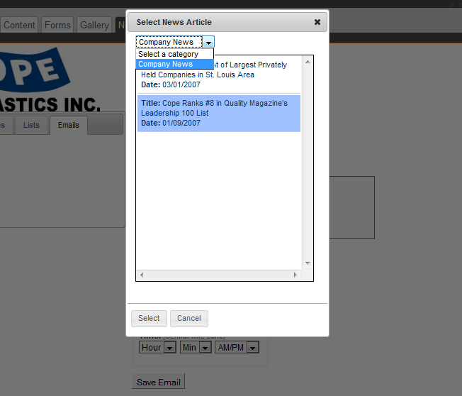

The selected article will then appear under the “select a news article” section.

Select Lists:
Click on the “select lists” text and a popup will direct you to check a box for the media list that you want to use for this release. Hit select and that list will be used.

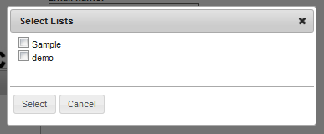

After you select the release and the media lists, they will appear within the system. If at any time you need to make a change, just click on the corresponding text and you can switch your selection.

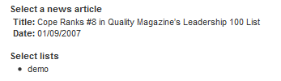

Note: You can select more than one list; however, since your lists are probably targeted to different industries, you may have a better success rate if you send it one at a time with a targeted intro paragraph for each individual email blast.

Scheduling Distributions:
The schedule distributions section allows you to schedule a distribution either for immediate distribution or for a future date. We recommend that distributions go out Monday-Thursday anytime from 10-3 CST so that the entire country is working when the distribution goes out. To schedule the distribution, either type in a date or select a date from the calendar function. Then schedule an exact time for the distribution. Releases have to go through a “review” period prior to going out, so in general schedule releases at least 30 minutes in the future.

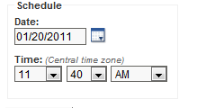

SAVE NOW!
After you complete these steps, you must save your email before proceeding in order to preview and launch the email. This is in place so that you don’t accidentally send the email during the initial set up process.

Sending Emails

After you save, you will notice that new options become available. Your email will also be listed as a draft. So you can save the email at any time and come back to it.

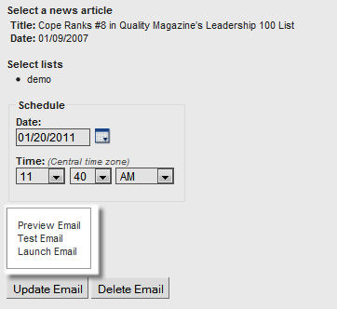

Preview:
When you click on the preview function, a popup will show how the email will appear in the blast. The {FIRST_NAME} section will be filled when the email is sent from the names entered into the list section of the Publicist.

The press release is featured below the introduction paragraph. As mentioned below, having this in the body of the email instead of being attached will not only ensure that it is read by more reporters, but it will also keep it from being marked as spam because you are sending an unsolicited email.

You can exit the preview by clicking the x in the right hand corner or the “close” button at the bottom.

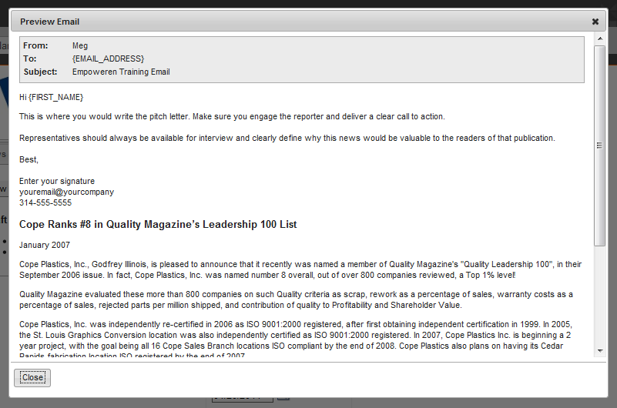

Test Email:
Prior to launching the email, we always recommend sending a test email. If possible, this email should go to a work account that uses Outlook or a similar program and other email services such as Gmail.

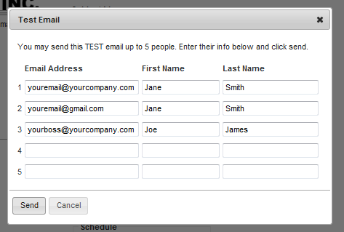

Tests will be sent in two formats, HTML and text format so that you can see exactly how it will come to reporters in their inboxes.

After you are happy with the test email, you can set the email to go out by selecting the “launch email” option.

Note: Scheduling an email does not automatically send the email. You must select the launch email option in order for the email to be delivered.

Your email will then be listed in the “Sent” column under the email tab.

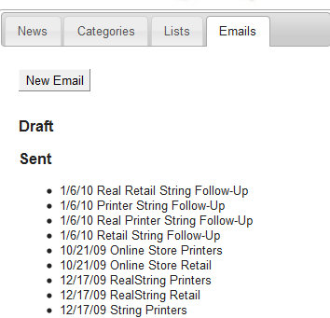

Delivery Data

If you click on a sent email after it is launched, you can see some basic metrics about the performance of the email. We suggest waiting at least 24-48 hours before viewing these stats in order to get an accurate picture.

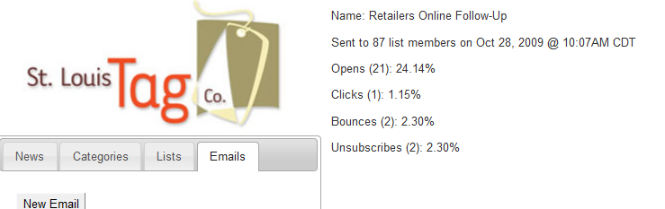

Opens: The number of people that opened the email whether in a preview panel or in a regular email.

Clicks: The number of people that clicked through a link in your press release to your company’s website.

Bounces: The number of emails that weren’t delivered for a variety of reasons including a full email inbox or a discontinued email address.

Unsubscribe: In order to comply with anti-spam policies, this option allows reporters to unsubscribe from future correspondence from you.

Follow Up:
About a week after you send the initial email, we recommend resending the press release to the same list with a quick note to check to see if they received the information and if they need anything else from you. Our experience shows that you can get measurably more responses from this second email.

If you have reporters that have responded in any way to your first email, make sure that you remove them from the main media list for the time being so that they are not sent your email again when they already responded.

To do this, start a new list such as “Industrial Pubs-Responded” and then use the list tab within each individual member profile to temporarily move those individuals to that list. Then it will be extremely easy to move people back into the main list for the next press release.

Note: If an editor asks to be removed from the list, please go into their individual member profile and remove them from all of your media lists. This is a professional courtesy and continuing to send them emails will not result in articles, it will only annoy that reporter further so that they will be even less likely to write about you.

