Photo Gallery Manager
Users Manual

Photo Gallery Manager

Uploading Images
To upload images for an image gallery, select the Gallery tab. Within the Gallery section, you will see an upload section on the left. Click the Upload File button, select the image to upload, and then click Open. This will upload the image and it will then appear on the right under All Images.

Folders
By default, every uploaded image will go into the All Images folder. To create additional folders within, click once on All Images and then select the menu icon and select on New Folder inside this.

Albums
To create and manage photo albums, click on the Albums tab in the Gallery section. This will show you a list of the existing albums. To create a new album, click on the blue + icon, enter the album name and click Save.

Descriptions
To add a description to a specific photo, you must first click on the Structure tab in the Gallery section. Also, at least one album must already exist. Next, select the name of the desired image within the folder in the bottom left area of the page. This will open up the photo, the title and date fields, and all of the available albums. Check the box next to the album that the photo will be included in and then click on the name of the album. This will open a new window where a description can be written and saved. After you click Save, the description will then appear below the name of the album.

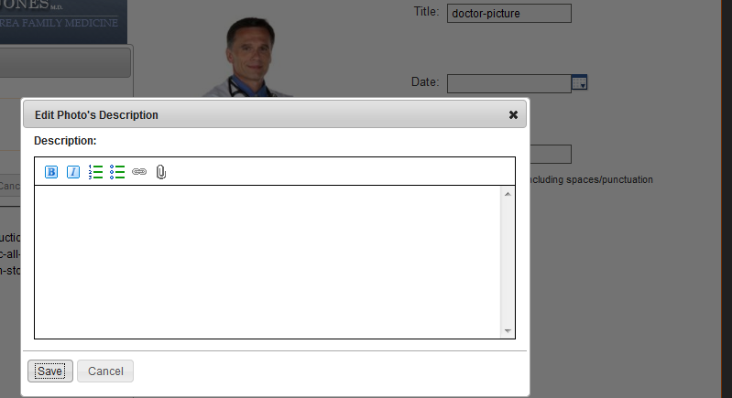

Image Names
To modify the name of an image, select the image from the folder in the bottom left area of the page. This will open up the photo page and you will just need to edit what is in the Title field and click Save.

Order
Within a specific album, you have the option to determine the order that the photos appear in the gallery. You can check the Alphabetical Order button or simply drag and drop the photos into the desired order. The photos will go in order from left to right and top to bottom. To delete a photo from the album, click the red X on the photo.

Views
There are three gallery views that you can choose from when inserting a gallery into the website.

Full View – The full view has a large photo with all other photos as thumbnails below it in a horizontal scrolling row. This view also has a box to the right that will show the description entered for the photos.

Mini View – The mini view is the same as the full view, only it doesn’t have the box to the right for a description.

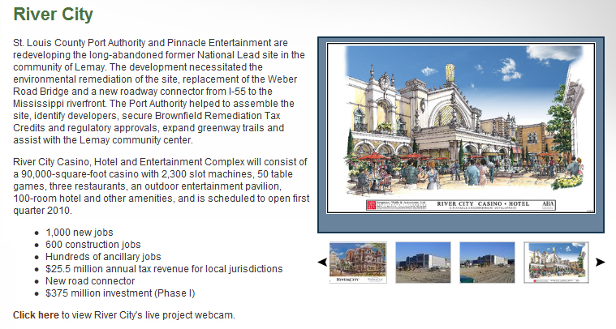

Light Box View – The light box view will display thumbnails of all the photos and when one has been selected, the rest of the screen will be darker and the photo will appear in the center of the screen. You can scroll through all of the photos in the album and descriptions will appear below the photo.



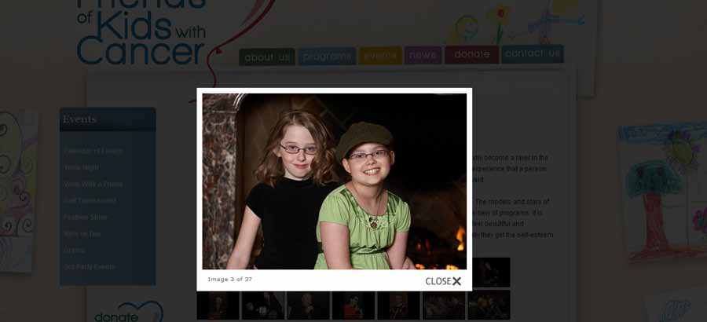

Inserting
The gallery will not be visible on the website until it is inserted into a page. To do so, go to the Content section and select or create the page that you would like to have the gallery displayed. Once the correct page is open, select within the editor box and then select the Photo Gallery icon from the bottom right section of the editor buttons. If you do not know which icon is the photo gallery, you can hover your cursor over the icon and a description will display.

Once the icon has been selected, a window will open for you to select the Album you would like to insert and which of the three views. Once you have made your selections, click Save and then click Publish on the page.

