Video Manager
Users Manual

Video
The Video Manager allows you to upload and display videos on your website without having to embed it as a YouTube video.

Uploading
You can upload a video from your computer as long as it is 1GB or less. To start, click on All Videos and then click the menu icon to display the box shown below. Select ‘Upload Video inside this’ and a window will open.

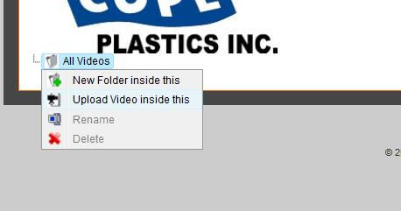

In the box shown below, you can enter the title of the video and then click the Browse button to select the video file from your computer. Once you have selected the video file, you can select High or Low quality and either 320x240 or 640x480 in size. Once you have made all selections, click the Upload button.

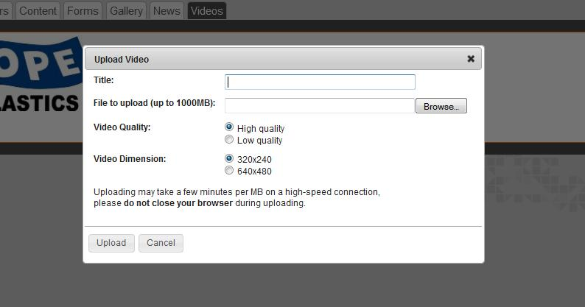

After clicking the Upload button, you will see the “Uploading…Please Wait…” message. This may take a few minutes, especially if the file size is close to the 1GB maximum. Once the video is done uploading to the server, it will automatically convert the video into a Flash format.

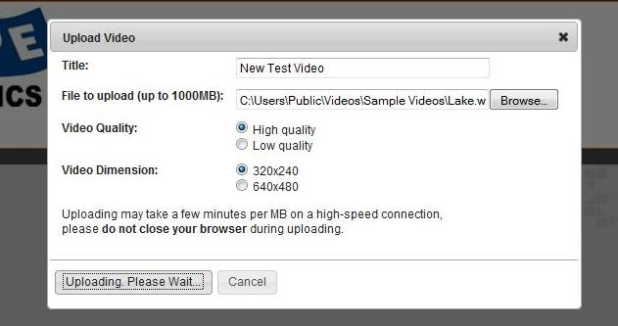

You will see a grey progress bar on the screen as it is encoding the file. Once it is complete, it will display that the video has successfully been uploaded & encoded.

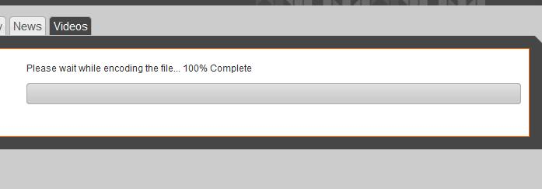

If you click on the title of the video on the left side of the screen, it will open the screen shown below that allows you to view the video or modify the title.
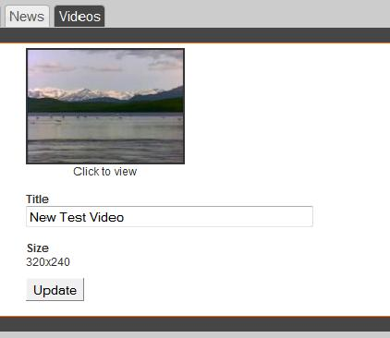

If you select the video to view, it will open in the format shown below and automatically start playing. You have the ability to expand the window to full screen or watch in the size provided. When you are finished viewing the video, click the close button in the bottom corner of the window.

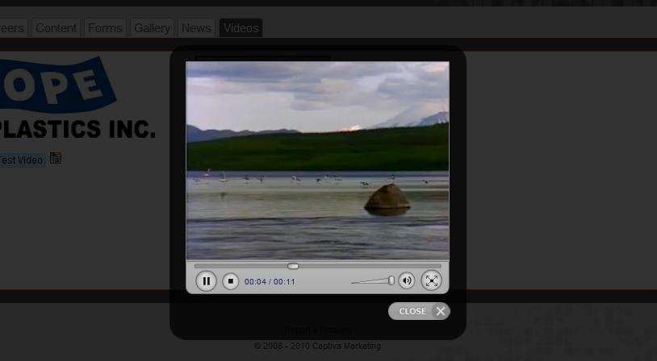

Inserting
Once you have successfully uploaded your video in the Video Manager module, you will need to insert the video on the desired page in the Content section. After selecting the appropriate page in the Content section, select the Insert Video button show below.

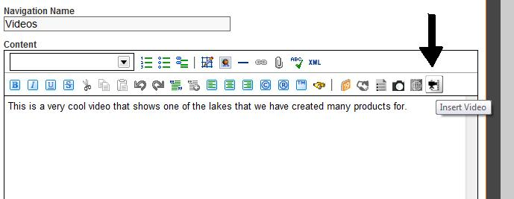

After you select the Insert Video button, a window will open requiring you to select the video you wish to insert. After highlighting the correct video as shown below, click the Add button.

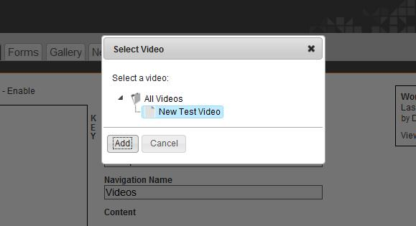

After clicking the Add button, the video will appear in the WYSIWYG editor as shown below. You do not have the ability to watch the video in this area. To modify the properties or make the text wrap around the video, you can double click on the video image and a window will open.
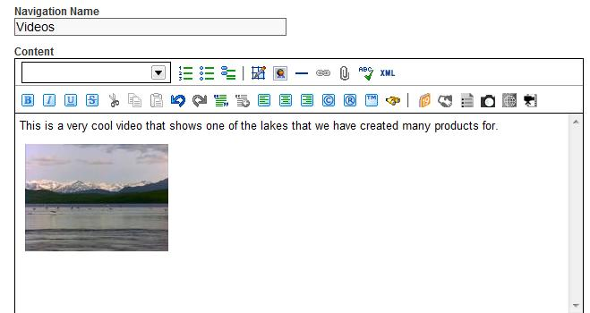

If you publish the page that the video has been added to and refresh the actual web page, you will now see the video displayed on the page as shown below.

