WYSIWYG Editor
Users Manual

WYSIWYG Editor
WYSIWYG (wiz-ee-wig) is simply an acronym for What You See Is What You Get because the WYSIWYG editor doesn’t require you to know code and it will display the page on the website the way it looks to you in the editor. There is a lot of functionality in this editor and it allows you to edit your website without having to hire someone who understands the code. Several features of this editor will be explained throughout this section.

If you would like more detailed information on the WYSIWYG editor, you may access the XStandard End User’s Guide.

Screenshot of WYSIWIG Editor with Empoweren Modules highlighted.
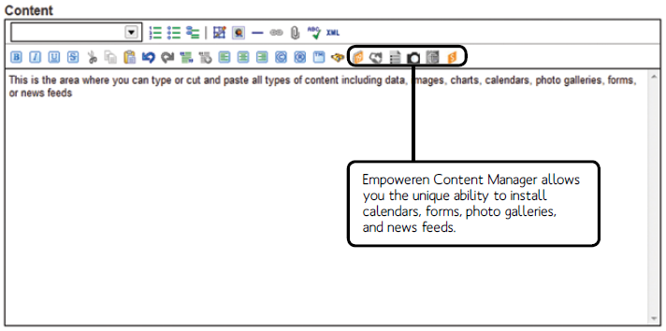

Adding Text
By clicking in the large text box of the WYSIWYG editor, you are able to begin adding text to a page. There are several options for ways that you can modify the text and most of those buttons are on the bottom row of the editor, just above the text box. They include: bold, italics, underline, strikethrough, cut, copy, paste, quotation, left align, center align, right align, and symbols like copyright, trademark, and registered trade mark.

Additionally, more options are available in the pull down menu in the top left corner of the editor. When you click on the pull down, you will see General, which has several more options, and Colors, which allow you to modify the color of the text.

Elements
The icons on the right side of the bottom row of the editor are elements that are custom to Empoweren. These icons allow you to easily insert elements such as forms, calendars, galleries, etc. that you have created in Empoweren. How to create these elements and how to insert them appropriately is explained further within their respective sections of the manual.

Bullet Lists
By selecting the icons to the right on the pull down menu, you can easily insert bullet lists, numbered lists, and definition lists to your web page.

Images
To insert an image, select the desired location within the editor and click on the image icon above. When the Image Library window opens, select an image and click OK. This will open the Image Properties window where you can enter the Alternate Text and modify the dimensions of the image. When you select OK, this will insert the image into the editor.

To modify the dimensions of the image after it has been inserted, click once on the image to highlight it and then select the image icon above.

Tables
Creating tables are an excellent way to format the content on your pages to ensure consistent formatting and alignment. To create a table in the editor, select the icon to the right of the bullet list icons. When selected, a drop down graph will appear. Without clicking, drag your mouse over the graph area. As shown below, the number of rows and columns will highlight in blue, as well as display at the bottom of the box as 4x4. Once you have highlighted the number of columns and rows you need, click and the table will be inserted in the text box.

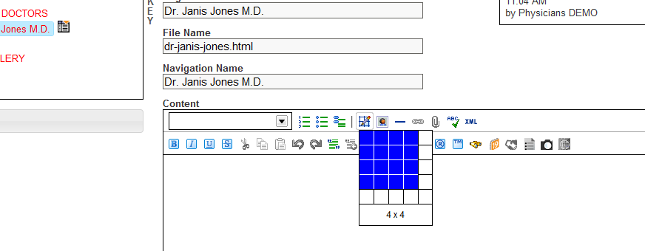

Now that the table has been created, you should be able to click inside any of the cells to add text or images. Nearly all table editing can be done by right clicking within the table. As shown below, there are options to add rows and columns, delete selected rows and columns, merge and split rows and columns, and modify the alignment within columns, rows, or cells.

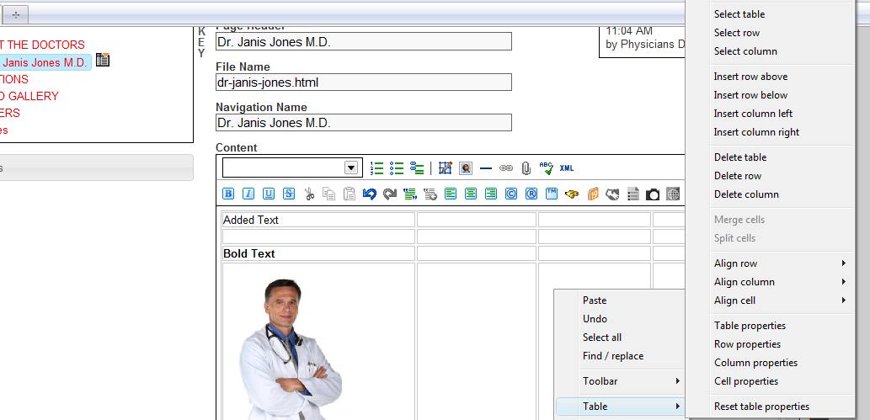

Links
Any image or section of text can be linked to another page within the website or a different URL. The desired text or image should be highlighted, then select the link icon and enter the URL.

*If the link is to another page within the website, only the file name following your domain name needs to be included. This is very important if you are building or editing a site that is not live yet (on the development server) because if you copy the entire file name like www.captiva2-webdev.com/yourdomain.html, the link will not work once the site is loaded on the live server and the domain switches from captiva2-webdev.com to your domain.

Attachments
Files can be attached to content by highlighting the text or image, selecting the paperclip attachment icon in the editor, and selecting the appropriate file. This will allow users to view the selected file by clicking on the appropriate link.

XML View
The XML button will switch the editor to the HTML view. This can be used to make specific HTML code modifications or insert Flash code and Java script. When you want to switch back to the standard view, click the XML button again and it will take you back.

